1. Content of build.sbt at project root

|  |
| --- |
| lazy val root = (project in file(".")).  settings(  name := "SparkSubmit",  version := "1.0",  scalaVersion := "2.11.8",  mainClass in Compile := Some("com.rsi.ingestion.SparkSubmit")  )  assemblyMergeStrategy in assembly := {  case PathList("META-INF", xs @ _*) => MergeStrategy.discard  case x => MergeStrategy.first  }  libraryDependencies += "org.apache.spark" %% "spark-core" % "2.1.0" % "provided"  libraryDependencies += "org.apache.spark" %% "spark-sql" % "2.1.0" % "provided"  libraryDependencies +="com.microsoft.sqlserver" % "mssql-jdbc" % "6.1.0.jre8"  //libraryDependencies +="com.github.benfradet" %% "spark-kafka-writer" % "0.4.0"  libraryDependencies += "org.apache.kafka" % "kafka_2.11" % "0.8.2.1"  libraryDependencies += "com.google.code.gson" % "gson" % "2.8.2" |

If we don’t want classed under jar we should add provided

By default we got plugin.sbt inside <name of project>/Project folder , when we build assembly jar from intellij it will not work , we have to rename it to assembly.sbt

Content of plugin.sbt or assembly.sbt file

|  |
| --- |
| addSbtPlugin("com.eed3si9n" % "sbt-assembly" % "0.12.0") |

Now either you can run **sbt assembly** command from terminal or you can use run assembly task in intellij

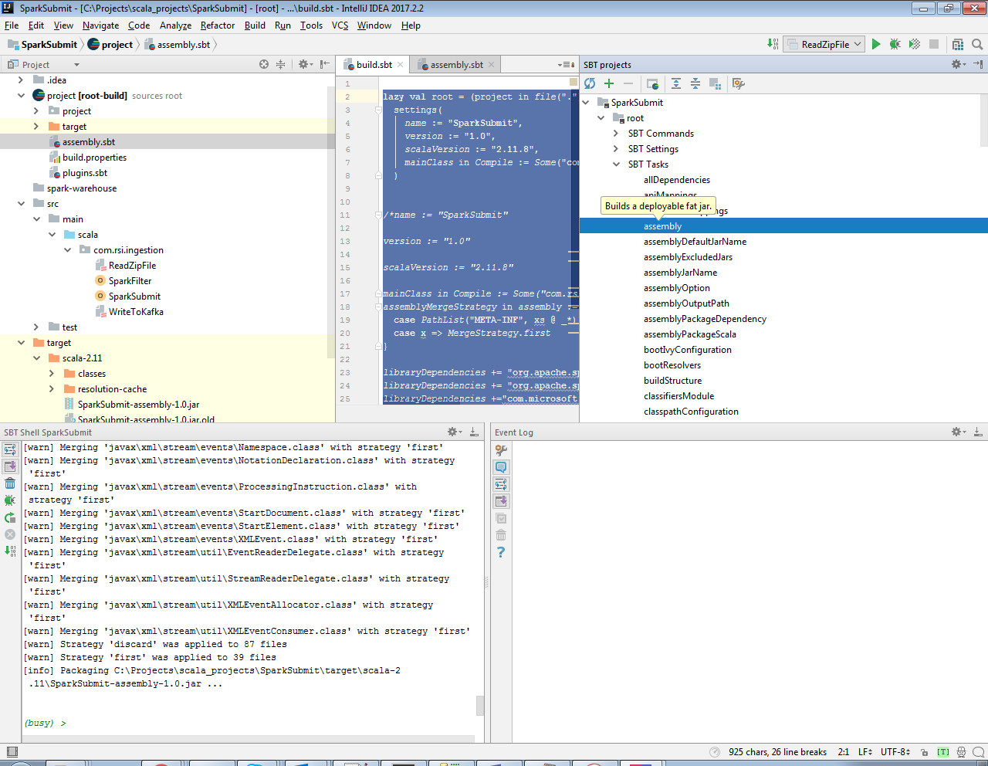

You will get file under <name of project>/target/scala-version directory